

DATA STRUCTURES AND ALGORITHMS
LABORATORY MANUAL
Name : Dihora Anandi
ID : 25DCE021
Program: B.Tech (CE )
Course: CSUC201 – Fundamentals of Data Structures and Algorithms Semester: III
Academic Year: 2026–27

Table of Contents
Practical No. | Aim / Title | CO Mapping | Page No.
1 | Array Operations: Traversal, Rotation, and Frequency Analysis | CO1, CO2 | 05
2 | Linear and Binary Search: Iterative and Recursive Approaches | CO1, CO3 | 08
3 | Sorting Algorithms: Comparison-Based, Counting-Based, and Digit-Based Strategies | CO1, CO3 | 11
4 | Singly Linked List: Dynamic Insertion, Deletion, and Traversal | CO1, CO2 | 14
5 | Doubly Linked List and Circular Linked List Operations | CO2, CO5 | 17
6 | Stack Implementation using Array and Linked List, with Expression Processing | CO2, CO5 | 20
7 | Queue Implementation using Array and Linked List, with Structure Simulation | CO2, CO5 | 23
8 | Binary Tree Traversals and Binary Search Tree Insertion | CO1, CO2 | 26
9 | Graph Traversal: Depth-First Search and Breadth-First Search | CO1, CO2 | 29
10 | Hash Tables: Linear Probing, Chaining, and Double Hashing | CO1, CO4 | 32

Practical-1 : Array Operations: Traversal, Rotation, and Frequency Analysis
Problem 1
Problem Statement
A bakery prepares n items every morning and places them in a display row. At the end of each hour, the leftmost item is moved to the rightmost position to make room for fresh stock at the front. Given the initial row and the number of hours h, print the final display order.
Describe the approach used. How does it behave when h is very large? Is there a way to get the correct result without performing the operation h times?
Key Questions / Analysis / Interpretation to be Evaluated During/After Implementation
1. [Problem 1] The display order repeats itself after a certain number of hours regardless of
how large h gets. Without trying any specific example, explain why this repetition is
inevitable and what determines when it first repeats.
Answer: The display order repeats because there are only a fixed number of possible positions.
The first repeat is determined by the number of elements and the pattern/order used.
Code
#include <iostream>
using namespace std;
int main()
{
int n, h = 0;
cout << "Enter Items:";
cin >> n;
cout << "Enter Time:";
cin >> h;
cout << "hour to rotate:" << h << endl;
int arr[n];
// int n1;
cout << "Item Enter :" << endl;
for (int i = 0; i < n; i++)
{
cin >> arr[i];
}
if (h > n)
{
h = h % n;
}
for (int j = 0; j < h; j++)
{
int first = arr[0];
for (int i = 0; i < n - 1; i++)
{
arr[i] = arr[i + 1];
}
arr[n - 1] = first;
}
cout << "Final Array is :";
for (int i = 0; i < n; i++)
{
cout << arr[i]<<" ";
}
return 0;
}

Output
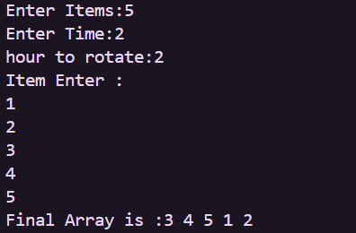
Problem 2
Problem Statement
A library issues books to students and records each book's ID every time it is borrowed. At the end of the month, the librarian wants to find all books that were borrowed more than once. Given the borrowing log, print all such book IDs.
Describe the approach used. How many times does your solution scan the data? If the library had 100,000 borrow records, would your approach still be practical? Can you think of a way that requires fewer passes?
Key Questions / Analysis / Interpretation to be Evaluated During/After Implementation
2. [Problem 2] If the same book ID appears three times in the log, should it appear once or
three times in your output? Does your solution handle this correctly, and how would you
verify it?
Answer: If a book ID appears three times, it should appear three times in the output.
We can verify this by checking the output count against the input log.
Code
#include <iostream>
using namespace std;
int main()
{
bool borrow;
int n, i1 = -1;
bool found = false;

cout << "How many book you Borrow: ";
cin >> n;
int count;
int book_ID[n];
cout << "Book ID: ";
for (int i = 0; i < n; i++)
{
cin >> book_ID[i];
}
for (int j = 0; j < n; j++)
{
count = 0;
for (int i = 0; i < n; i++)
{
if (book_ID[j] == book_ID[i])
{
count++;
}
if (count > 1)
{
i1 = book_ID[j];
found = true;
break;
cout << "count: " << count << endl;
}
}
}
if(found){
cout<<"More then one Borrow bOOK ID: "<<i1<<endl;
}
}
Output
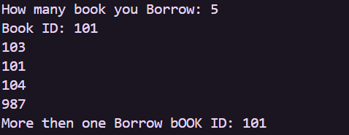
Problem 3
Problem Statement
A school newspaper editor wants to highlight the most impressive word from a submitted article. The word is chosen simply by length—the longest one wins. Given a sentence, print the winning word and how many letters it has.
Describe the approach used. What does your solution do when two words have the same length? Is that behavior intentional, and can you think of a way to handle it explicitly?
Key Questions / Analysis / Interpretation to be Evaluated During/After Implementation
3. [Problem 3] The editor later decides that punctuation attached to a word (e.g. “hello,” or
“great!”) should not count toward its length. How would this change your solution, and at
which step would you handle it?
Answer: Remove punctuation before calculating the word length.
Handle it during the word-processing/cleaning step.
Code
#include <iostream>
#include <string>
#include <vector>
#include<algorithm>
using namespace std;

int main()
{
string str;
int sum = 0;
int count = 0;
int space = 0;
int last;
getline(cin, str);
vector<int> v;

for (int i = 0; i < str.length(); i++)
{
if (str[i] != ' ')
{
count++;
}
else
{
sum = sum + count;
v.push_back(count);
space++;
count = 0;
}
}
last = str.length() - sum - space;
v.push_back(last);

auto it= max_element(v.begin(),v.end());
cout<<"Max element is: "<<*it<<endl;

return 0;
}
Output
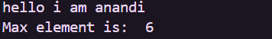

Conclusion :
• Understood the problem statement and designed a suitable algorithm.
• Implemented the solution in C++.
• Tested the program using sample inputs and verified the output.
• Improved logical thinking and problem-solving skills.
• Learned to analyze time and space complexity.

